Generic System-of-Systems Description (GSoSD)

The Arrowhead Support Systems

**Abstract**

This document defines the 5th generation of the Arrowhead Support microsystems. It provides a high-level architectural description of what problems the Support microsystems solve, how these microsystems can interact, as well as how they may be applied to practical use cases.

The primary purpose of the document is to outline the functionality offered by the Arrowhead Support microsystems. Its architectural aspects are defined in the abstract, by which we mean that no specific implementations or technologies are endorsed or mandated, respectively.

Table of Contents

1.System-of-Systems Overview 3

2.Systems 3

3.Use-cases 3

3.1. Onboarding 3

4.Release Notes 4

5.Non-Functional Requirements 4

5.1. Caching 4

6.References 4

7.Revision History 5

7.1. Amendments 5

7.2. Quality Assurance 5

1. Overview

**Work in progress.**

1. Systems

**Work in progress.**

1. Use-cases

**Work in progress.**

# Onboarding

**Work in progress.**

As the Arrowhead architecture relies extensively on the ability to store metadata about systems, for purposes such as orchestration, choreography, and so on, there must be a way to unambiguously refer to each system in every local cloud. That unambiguous reference is what we refer to as an *identity,* and the process of providing an identity to a system we refer to as its *onboarding*. Identities may be simple text descriptions, serial numbers or cryptographic public key pairs, depending on the requirements of the local cloud in question.

The onboarding process is executed through five steps, illustrated in the below figure. The details of step 3 depend on how identities are represented.

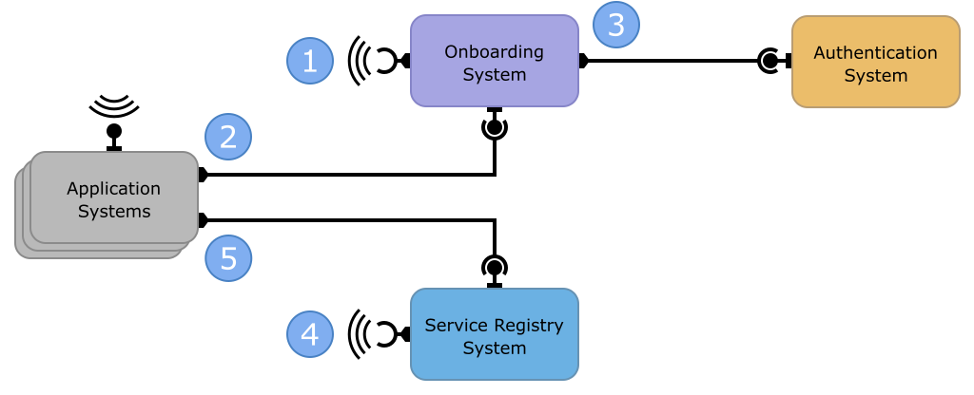

1. The Onboarding System announces its existence periodically through messages sent without a specific recipient. The message is received by all systems in the same local cloud that expect and can react to the message.
   1. An alternative to this step is to have the network address of the onboarding system distributed in advance to all systems to be onboarded.
   2. Every system receiving the announcement must be able to determine if they trust the message and its sender.
2. Every system looking to be onboarded that receives the announcement of the Onboarding System attempts to onboard via its Onboarding service.
   1. The onboarding system may have to provide a proof that it is expected to be onboarded, such as a manufacturer’s certificate or a secret.
3. The Onboarding System contacts whatever system in the local cloud responsible for maintaining a registry of identities. The purpose of the communication is to produce a new identity for the onboarded system. When a new identity is registered, it is relayed back to the onboarded application system.
4. The Service Registry System announces its existence periodically through messages sent without a specific recipient. The message is received by all systems in the same local cloud that expect and can react to the message.
   1. Alternatively, the address of the Service Registry System can be provided by the Onboarding system when it responds with the new identity to the onboarded system.
   2. Every system receiving the announcement must be able to determine if they trust the message and its sender.
5. The onboarded application system registers the services it provides via the Service Discovery service of the Service Registry System.
6. Release Notes

**Work in progress.**

This section describes the differences between current version and previous versions of the architecture.

1. Non-Functional Requirements

**Work in progress.**

# Caching

In order to increase autonomy and robustness caching of AH Core service content is advised.

1. References

**Work in progress.**

1. Revision History

# Amendments

|  |  |  |  |  |
| --- | --- | --- | --- | --- |
| No. | Date | Version | Subject of Amendments | Author |
| 1 | 2023-02-24 | 0.1 | Initial draft. | Emanuel Palm |

# Quality Assurance

|  |  |  |  |
| --- | --- | --- | --- |
| No. | Date | Version | Approved by |
| 1 | YYYY-MM-DD | 1.0 | Nnnnn Nnnnnnn |
| 2 |  |  |  |